**BETWEEN CLAUSE:**

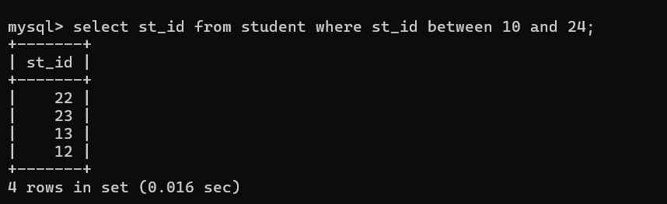

**IN CLAUSE:**

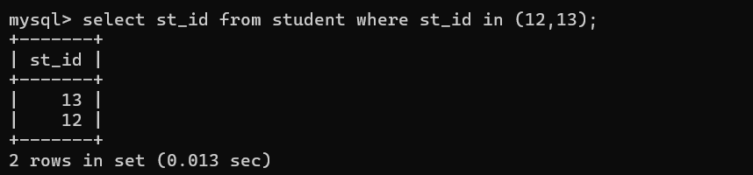

**AGGREGATE FUNCTION:**

